Cooperatives and the Concept of
Brotherhood Economics

Introduction to an idea

Most people are acquainted with the communal roots of Christianity. Many Christian congregations also pay great attention to the concepts of community, social action, and other important values related to group action. Few are aware of the cooperative movement, however, and even fewer know of the role that some Christian denominations individuals have played in it.

Cooperatives can be thought of as economic tools for achieving goals through democratic group action. Cooperatives differ from capitalism because the benefit of the member, who receives the benefits of the cooperative, is seen as more important than the benefit of investors. That is to say, people are valued over money, both in services and in decision making, where democratic control by those receiving benefits takes the place of hierarchical control based on the amount of money invested.

Co-ops are also far different from state socialist or communist models, which rely on a top-down approach to solving problems. Cooperatives place power in the hands of the people, rather than in the hands of a patron body which provides benefits from on high. In this sense, co-ops also differ from charities, which are really modeled on ancient feudal concepts of obligation of the wealthy few to serve the needs of the less fortunate.

Particularly during the Great Depression, when many were seeking alternatives to the dominant economic systems of the time, cooperatives were seen as a “middle way.” But to some Christian thinkers, co-ops represented something more than just a bland alternative to capitalism, fascism and communism. One of them, Tyohiko Kagawa, a Christian minister in Japan, coined the phrase “Brotherhood Economics” to describe that greater concept

In the conclusion to his book by this name, Kagawa wrote:

If we leave economic activities, as they are to-day, the peace of the world will never be established. Neither will religion in its present state ever realize world peace. Peace will come only when the consciousness of redemptive love as manifested on the Cross permeates the life of international economy through brotherhood love evidenced in the cooperative movement. So…let us without delay endeavor to cooperatize the economic system of the world. With this accomplished, we shall find that we have built the only sure foundation for the establishment of world peace.

Cooperatives as a tool for social change

In 1844, in the small community of Rochdale, England, the first cooperative was formed which followed the principles guiding most cooperatives in the modern world. The Rochdale Society of Equitable Pioneers drew its membership primarily from the poor weavers who worked in the mills of Rochdale.

Also of importance to today’s cooperatives was the Raiffeisen system of credit, originating in Germany, which led to the modern credit union movement. Today, credit cooperatives and credit unions are among the largest democratically controlled economic systems in the world.

From the beginning, cooperatives were conceived of as ways for a group of people to solve their problems. For the poor weavers of Rochdale, safe and reasonably priced groceries and dry goods were an overwhelming concern, but they also hoped to start industries, build housing, and in other ways create an economic system of, by and for the people. In Germany, a man named Herman Schulze of Delitzsch applied these cooperative principles to the development of City Credit Cooperatives, and Frederick Wilhelm Raiffeisen then applied these to Rural Credit Cooperatives.

The needs of consumers and farmers drove these efforts and guided them. Many Christians were involved in these very early developments, as they have been in subsequent efforts over more than 160 years. The remainder of this paper will focus on the efforts of just a few of those motivated Christians who have worked to change the world through economic cooperation.

Dr. Moses M. Coady

When St. Francis Xavier University in Antigonish, Nova Scotia began to work in the field of adult education in the 1920s, no one expected the Great Depression. But in 1928, Rev. Moses Coady became the head of the school’s Extension Service just as an already bad situation became close to impossible.

Coady saw solutions in terms of empowerment, which in turn meant for him an educational process through which the common people could understand their problems and find ways to solve them. Cooperatives were an easy extension of this concept, particularly for a rural people who knew each other well and understood the advantages of both self-help and group action.

Coady labored mightily and successfully, eventually creating what we now know as the Antigonish movement in Nova Scotia. The website of the Coady Institute at St. Francis Xavier outlines the basic principles:

- The Primacy Of The Individual. This principle is based on both religious and democratic teaching: religion emphasizes the dignity of human beings, created in the image and likeness of God; democracy stresses the value of the individual and the development of individual capacities as the aim of social organization.

- Social Reform Must Come Through Education. Social progress in a democracy must come through the action of citizens; it can only come if there is an improvement in the quality of the people themselves. That improvement, in turn, can come only through education.

- Education Must Begin With The Economic. In the first place, the people are most keenly interested in all concerned with economic needs; and it is good technique to suit the educational effort to the most intimate interests of the individual or group. Moreover, economic reform is the most immediate necessity, because the economic problems of the world are the most pressing.

- Education Must Be Through Group Action. Group action is natural because people are social beings. Not only are people commonly organized into groups, but also their problems are usually group problems. Any effective adult education program therefore, must fit into this basic group organization of society. Moreover, group action is essential to success under modern conditions; you cannot get results in business or civic affairs without organization.

- Effective Social Reform Involves Fundamental Changes In Social And Economic Institutions. It is necessary to face the fact that real reform will necessitate strong measures of change that may prove unpopular in certain quarters.

- The Ultimate Objective Of The Movement Is A Full And Abundant Life For Everyone In The Community. Economic cooperation is the first step, but only the first, towards a society that will permit every individual to develop to the utmost limit of her/his capacities.

During its early years, the field workers of the Extension Department would go from community to community, meeting with groups of neighbors in living rooms and kitchens across Nova Scotia. Out of their efforts, hundreds of cooperative associations were organized, including farm co-ops and fisheries, stores and credit unions.

Today, the Coady Institute at St. Francis Xavier serves the whole world, as nearly 4,000 leaders from 120 countries have participated in their campus-based programs. The Rev. Dr. Coady, thanks to his keen insight, began a movement based on Christian concern for human dignity and empowerment that continues to benefit the world today.

Rev. Toyohiko Kagawa

Jack and Connie McLanahan, who wrote of many cooperative leaders, said of Kagawa:

As a Christian, [Kagawa] considered co-ops the natural expression of brotherhood economics. 1914-16, studied for/received Bachelor of Divinity Degree from Princeton University; traveled and lectured across the US; again in 1924-25, and in 1935-36. In the latter tour he spoke to audiences that totaled into the thousands – inspiring them to consider and organize co-ops as a way of dealing with the worldwide financial depression and developing a new and more ethical economic order.

Kagawa’s American biographer, Robert Schildgen, described Kagawa’s life in heroic terms:

. . . [Kagawa became] one of the most influential social reformers and religious leaders in Japan and perhaps the most famous and revered Japanese figure in the rest of the world during the 1930s. A convert to Christianity, he was one of those rare and troublesome Christians who decided to live the Gospel quite literally, dedicating himself to the poor by giving all he owned, whether material or emotial resources. He fed, sheltered, nursed, educated and preached in the slums at tremendous risk to his own health, contracting the painful eye disease, trachoma, which plagued him thoufh his life, and risking a recurrence of tuberculosis which had almost killed him twice before he plunged into the slums.

Time after time, Kagawa risked his life not only by living and working in the slums of Tokyo, but also through his work as an organizer and pacifist in wartime Japan. He worked to organize labor unions as well as cooperatives, but it is his work as the godfather of the Japanese cooperative movement for which he is most revered. In the lobby of the high rise building which serves as headquarters for the Japanese consumer cooperatives, he is memorialized through a giant bust. In the offices and histories of the university cooperatives he is also seen as the founder and guide for their movement, now with 1.25 million members.

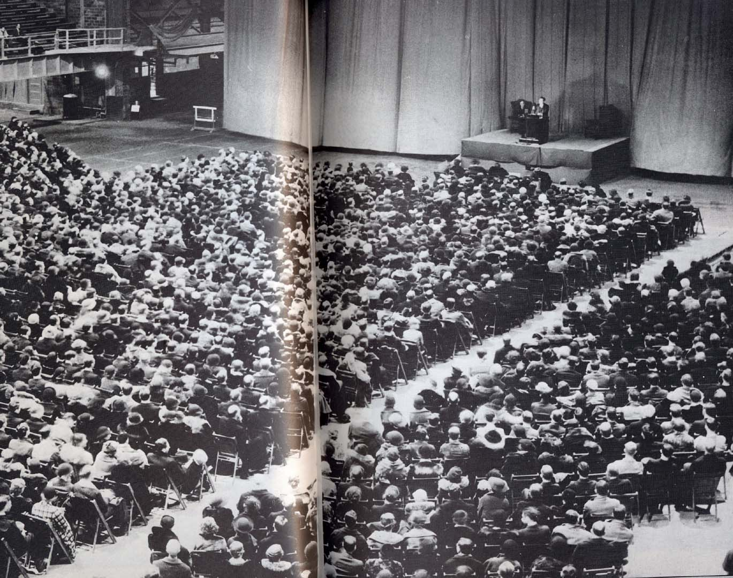 (photo)
Toyohiko Kagawa, speaking to an audience in Iowa about cooperatives and social justice in 1931.

Kagawa, through his travels in the United States, also was seen as a leader and founder. He is the only person born outside of America to be inducted into the National Cooperative Hall of Fame in Washington. Through his speaking tours, Kagawa inspired Americans from all walks of life to find solutions in cooperative effort. Student cooperatives in particular were invigorated by his ideas, largely because many of his speeches were delivered on university campuses. Campus Cooperative Residence, Inc. in Toronto, the oldest housing co-op in Canada, was started directly after one of his presentations, and a house there is named after him.

In Japan, Kagawa was sometimes a minister for the Church of Christ (Japan), and sometimes occupied full time in his organizing activities. But today a church stands in the heart of Tokyo with a large museum section that is devoted to his memory. His ideas of Brotherhood Economics are little remembered in the United States, but in Japan his ideas have become an important reality benefiting millions.

Father Marion M. Ganey

Some cooperative heroes receive more press than others – and Father Ganey rarely sought recognition for his efforts. As a result, a search of the web reveals only scattered references to his work, but when put together the result is close to stupendous.

The web archives of the Credit Union National Association outline the beginning of Ganey’s involvement with cooperative lending:

The perils of organizing credit unions in remote areas of the world could be daunting. Missionaries carried the credit union idea as an instrument of social justice to native peoples of Africa, Latin America and the Pacific islands. In doing so, they faced the frustrations of dealing with prejudiced government officials who were convinced that no "native" could "manage" anything, and especially not money. Then there were the loan sharks, who were not above using violence to protect the monopoly they held on the local money lending business. Finally, there was at least the potential of violating some local taboo with dire consequences. But, despite these difficulties, the missionaries continued to preach credit unions along with faith to the people they served.
One of the first of these missionary credit unionists to brave the perils was Marion M. Ganey, S.J. He went to British Honduras in 1943 and found the activity of loan sharks there so repugnant that he immediately began a search for some means to alleviate the plight of their victims. He discovered that some of them were charging interest rates of 100% per month. A farmer who borrowed 35 pounds for implements had paid one-third of his crop to a shark for eight years and still owed hundreds of pounds in interest. To Father Ganey, such conditions were intolerable. In his research for a solution, he discovered the credit union.
Part of his mission became a practical program to educate the people in managing their own finances, giving them control over their own economic future. Government red tape to obtain legislation for credit unions was frustrating. Fortunately, Sir Ronald Garvey, the governor-general of Honduras, understood and supported the concept of credit unions, and he assisted Father Ganey in getting t he necessary legislation passed. The first credit union, St. Peter Claver, opened in Punta Gorda in 1943. A local loan shark vigorously objected and suggested to the bishop that Father Ganey should be stopped as an "imposter." "I have looked everywhere in the Christian Bible," he told the bishop, "and nowhere do I find the words, ‘credit union.’" Over the next decade, Ganey established other credit unions in Honduras which had a significant impact on reducing the activity of loan sharks.

After leaving British Honduras (now known as Belize), Ganey was sent by the Church in 1953 to Fiji, where he began his work anew. He originally planned to stay for just six months, but as he saw the conditions and the need, his stay continued – for decades. In 1970, after a tremendous amount of dedication and effort, a Cooperative League had been established in Fiji and a training Center built in Suva, the capital.

What is not told in the CUNA web pages is that the idea of credit unions spread from Fiji to the Solomon Islands, thanks to the interest of Rev. Bishop Dudley Tuti, and to New Zealand, where Rev. Ganey spoke about the importance of a credit union movement at a seminar.

I had the privilege of meeting Father Ganey during a study trip to Fiji in 1980. I was frankly overwhelmed by his dedication to cooperative saving and lending, and to serving the small villages where no other options for credit were available. I asked him how, as a Catholic priest, he had been able to spend his life organizing credit unions. He replied that he was just lucky, and that he’d been able to convince his superiors to let him do the work that was needed.

Rev. Alf Clint

Brotherhood Economics, Toyohiko Kagawa, Harper & Brothers, 1936.
Ibid, page 196.
Coady International Institute , St. Francis Xavier University; http://www.stfx.ca/institutes/coady/text/about_antigonishmovement.html
Toyohiko Kagawa, Apostle of Love and Social Justice. Robert Schildgen, Centenary Books, 1988; page 1.
Kagawa Toyohiko, Kagawa Toyohiko Photo Collection Publication Group, Japan, 1988; pages 50-51.

