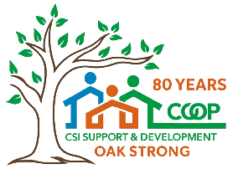
People Working Together to Help Each Other
CSI’s Cooperative Management Model
for Affordable Senior Housing

Pete Steffy, Education Coordinator: pete.steffy@csi.coop, (586) 578-0245
Roland Pascua, Human Resources Manager: roland.pascua@csi.coop, (586) 753-9019

Affordable Housing Crisis and Housing Challenges for Seniors
- The United States is facing a significant shortage of affordable housing
- For the 10.9 million households ranked “extremely low income,” only 7.1 million housing units are available that meet their affordability requirement. For the 17.7 million households ranked either “low income” or “extremely low income,” only 15.6 million units are available. (source: National Low Income Housing Coalition)
- In Michigan, approximately 39 rental homes are affordable and available per 100 extremely low-income renters. (source: National Low Income Housing Coalition)
- As the population of older adults grows, the affordable housing crisis has the potential to have a disproportionally large impact on this often vulnerable population.
- Whether residing in senior housing facilities or elsewhere, many older adults experience social isolation and loneliness, which are associated with increased risk of heart disease, dementia, stroke, anxiety and depression.
- Self-reported numbers from the National Poll on Healthy Aging show that 29% of older adults felt isolated from others some of the time or often. This number is significantly down from 56% during the peak of the COVID-19 pandemic. (source: University of Michigan Institute for Healthcare Policy and Innovation)

History and Background of CSI Support & Development
- CSI Support & Development Services is a resident/member controlled organization that utilizes a cooperative management system and engages its resident membership in decision-making at every level of its operations. Our organization was incorporated in 1945 as a mission-driven non-profit and we exist solely to provide the highest quality, affordable housing communities possible for seniors.
- Fred Thornthwaite built the core of what became CSI by organizing the Parke Davis Credit Union and participating in the Co-op Homesteads for families in Madison Heights, Michigan. Residing in the Co-op House in Highland Park, he promoted
co-ops at union meetings, motivated and inspired young people at student housing co-ops in Ann Arbor, and worked at Metro Co-op in Detroit. Out of this work, Cooperative Dairy Services began, with 20 to 25 members, 12 of whom put up $20 each as a down payment on a co-op milk route. Cooperative Dairy Services grew and in 1945 purchased Wyandotte Dairy from the cooperative’s savings of $5,000. The business eventually had 18 milk routes, 3 stores and 18 outdoor milk vending machines which were positioned mainly at gas stations. Cooperative Dairy Services shared education meetings with Fordson Cooperative, owner of a grocery store and a gas station and sponsor of Co-op Services Credit Union. In 1958, Cooperative Dairy Services and Fordson Cooperative merged and formed Cooperative Services, Inc. Co-op Services Credit Union is still under the sponsorship of Cooperative Services, Inc. and has become one of the largest of its kind in Michigan.
- In 1965, after a five-year process with the Federal Housing Authority, Wyandotte
Co-op Apartment was built to provide 160 apartments for the elderly of low and modest income. Rents were as low as $100. The building’s future residents had regular meetings about their cooperative when the building was still under construction. Once moved in, the new members eagerly joined committees and elected officers and floor representatives.
- The dairy closed in 1968 but was soon replaced with another cooperative venture, Co-op Optical Service. As a division of Cooperative Services, Inc., its goal was to provide consumers with low-cost eye exams and glasses. Labor unions and city employee groups added optical care from Co-op Optical to their contracts. The business grew by the late 1970s to include a lens grinding lab, and nearly a dozen retail outlets in the southeast Michigan area. In the early 1980s, Co-op Optical was separated from Cooperative Services to become an independent cooperative.
- Since the 1970s, CSI has worked for sustainable growth in the senior housing market using available funding opportunities:
  - 1970s – 6 new co-ops built
  - 1980s – 12 new co-ops built or acquired, including expansion to Maryland, Massachusetts and California
  - 1990s – 19 new co-ops built
  - 2000s – 14 new co-ops built
  - 2010s – 6 new co-ops built or acquired
  - 2020s (so far) – 6 new co-ops built or acquired
- CSI currently manages 65 properties in four states, with 7,022 total housing units.
- In recent years, focus has shifted towards acquisitions and improvements on existing properties, and HUD funding programs have become increasingly limited.

CSI’s Organizational Structure

Mission Statement: Using cooperative principles, CSI develops and manages exceptional, affordable rental communities where seniors enjoy opportunities to thrive.
Vision Statement: To preserve and grow our cooperative senior housing communities, helping members lead full, healthy social lives.
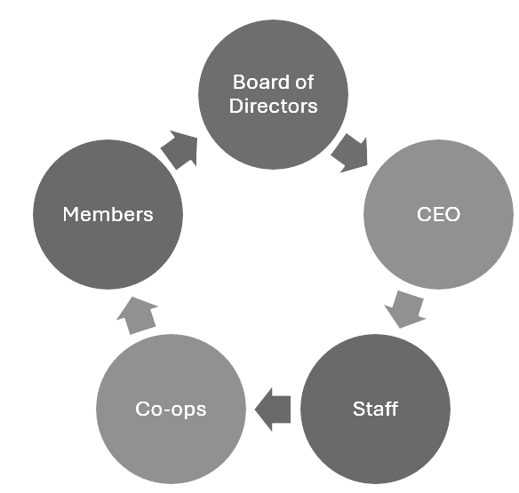
- Co-ops are managed cooperatively and collaboratively by resident-members and CSI Support & Development
- Resident-members elect the Board of Directors
- Board of Directors hires and evaluates the CEO
- CEO hires and evaluates staff
- Staff provide training and support for co-ops, along with direct management when necessary

How Our Co-ops Operate
- Buildings are cooperatively managed, but not cooperatively owned.
- All residents are automatically members of the co-op where they live, and of CSI.
- Resident-members elect council members annually.
- Council members make decisions affecting management and conduct day-to-day business.
- The council and general membership meet monthly.
- The president appoints committee chairs.
- Volunteers receive training and support from co-op liaisons and education department .
- The pamphlet “Welcome to Co-op Life” presents a distilled version of how our co-ops operate, presented in a way that’s accessible for members who may have no background with co-ops.

Main Benefits of Using a Cooperative Management System in Affordable Senior Housing
- It makes each community a better place to live, because the members have direct input into decisions that impact their lives.
- It creates transparency in how things are managed, giving the members an understanding of how the co-op’s resources are being used.
- It provides structure, activities, continuing education and social engagement for seniors to help keep them active and healthy.
- Volunteering is completely optional, so it’s up to each member how involved they’d like to be.
- It introduces the co-op system to many people who have never been part of a
co-op before and were just looking for an affordable place to live.
Educational Programs for Volunteers
There’s a constant cycle of new volunteers with a vast range of previous experiences and skill sets, making regular and comprehensive trainings opportunities essential.
- Officer Orientation: Annual full-day introductory training for co-op presidents, vice president, secretaries and treasurers
- Council Training: Annual training held at each co-op by the liaison for all incoming council members
- Management Conference: Annual conference presented by staff
- President/Vice President Meetings: Monthly discussion forums on Zoom
- Treasurer Update Training: Mid-term update for treasurers
- Continuing Education for Council: Mid-term update and discussion forum for all council members across different co-ops
- Congress Meetings: Link between each co-op and the Board of Directors
- Leasing Certification Training: Fair housing training for public-facing volunteers
- Leasing Forums: Fall, spring and summer discussion forums for leasing volunteers
- Leasing Conference: Conference presented by staff and volunteers
- Education Chair Training
- Elections Chair Training
- Pest Control Committee Training
- Fire Marshal Training
- Growing Committees Training
- Other trainings as needed
Showing Appreciation
Recognizing volunteers regularly helps boost volunteer spirit, encourage others to get involved, and remind co-op volunteers how important their work is.
- Officer Appreciation Luncheon
- Leasing Appreciation Luncheon
- CSI Volunteer Appreciation Luncheon
- Co-op Volunteer Appreciations
- Culture of appreciation

Staff Training, Support and Company Culture
- Departments
  - Operations/Liaisons
  - Education
  - Human Resources
  - Accounting
  - Certification
  - Leasing
  - Waitlist
  - Finance
  - Development
  - Facilities
  - Service Coordinator
  - Support (IT, Administrative)
- Staff can elect to become members of CSI, allowing them to vote on corporate bylaws changes and in Board of Directors elections, and attend the annual meeting. Staff do not vote in any co-op specific matters.
- CSI’s company culture is heavily influenced by cooperative principles, CSI’s motto, “people working together to help each other,” and core values of cooperation, education, excellence, integrity, respect and volunteerism.

Applications for Other Cooperative Organizations
- Cooperative management when cooperative ownership is not possible
- Strategies for member engagement
- Education and training
- Legislative action

Notes/Main Takeaways
__________________________________________________________________________________________________________________________________________________________________________________________________________________________________________________________________________________________________________________________________________________________________________________________________________________________________________________________________________________________________________________________________________

