HOW TO USE uDig FOR COOPERATIVE HOUSING MAPS
by David Arfa (Stone Soup Coop- Ashland House, Chicago) for NASCO Institute 2010

Installing uDig-
Download the open source GIS software uDig at the following site: http://udig.refractions.net/
Install and open uDig

Starting a map project-
Open uDig through Start> All Programs> uDig 1.2.0> uDig
Then in uDig, go to File> New> New Project
Give your project a name based on the theme of your map
You will see four sections in the uDig dialog box:
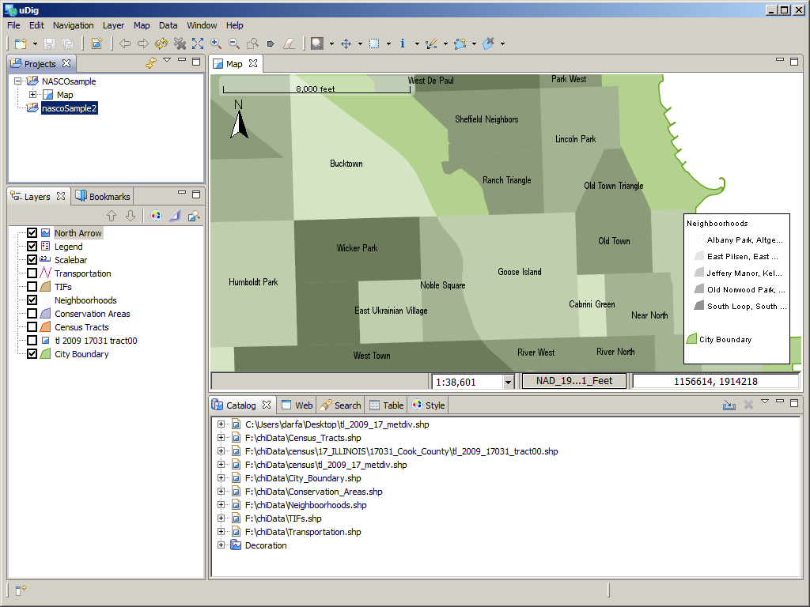
The Projects box lists all the projects you are developing
The Layers box lists all the layers you have added to your map
The Map box shows the display of your map
The Catalog box has many tabs- "Catalog" tab shows the file sources of your layers (keep your files organized), "Table" tab displays the table related to a data layer (highlight a data layer in the Layers box and click the "Table" tab to see the table)

Adding layers-
Download shapefiles that you need for your map from trusted data sources
In the main menu at the top click Layer> Add...>Files
Then browse to the shapefile you downloaded, it will end in ".shp"
Add all the layers you need for your map

Exploring data-
Highlight a layer in the Layers box and click the "Table" tab in the Catalog box. You may get a warning don't worry about it.
Now you can see all the attributes that are a part of your layer
You may see things like name or different numeric values. Each column in the table represents one attribute. The attribute title is at the top. Each attribute was considered important to the creator of the data. How can it be useful to you? What do you want to highlight?
For example, any of these attributes could be used to Label or Symbolize your data. For example, you may have an attribute that shows the name of each neighborhood- that could be shown on the map as a label. Or you could have an attribute that shows a numeric value like income level that could be shown as a series of colors on the map.

Symbolizing Data-
To change the way a layer looks in the map you need to change its "Style". Highlight the layer you want to manipulate and right click. Then go to Change Style... (it has a little painter's palette icon) next to it.
This will open a dialog box like this:
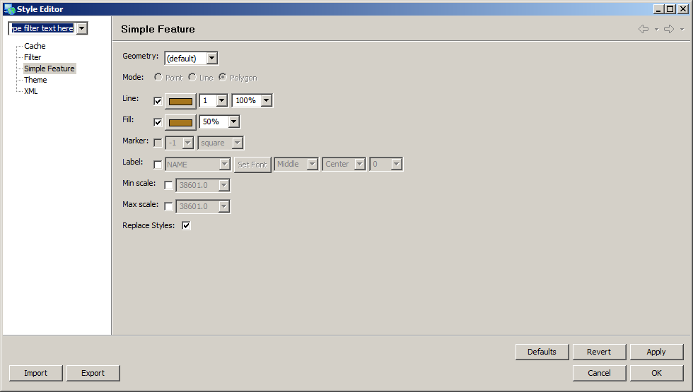
With this menu you are able to manipulate things like the color of a feature. For a polygon feature you can manipulate the color of the border and the color and opacity of the fill.
Click on the color next to Line: or Fill: to see the options and change the color. For Fill or Line you also have an option to change the opacity of the layer. Change the percentage to change the opacity- the lower the percentage the more transparent the layer will become. You can also change the thickness of the border line with the numeric drop down next to the color.
You also have the option to label features. Check it on if you want to label the features. Then, in the next drop down menu, choose the attribute that you want to use as the label. You can also specify the font, size, and the placement of the label. A rule of thumb is to have labels that are easy to read, so don't choose a very decorative font and they should not be smaller than 8 pt.
Labels take a lot of memory to display and may slow down your map a lot. That is why underneath the Label option you can tell the program not to draw a map only within a certain scale. So if you set a Max scale for your labels, the program will not draw the labels once you zoom out beyond that scale.
You will realize quickly Labels can be very tricky because sometimes they overlap each other or block something else, so you will need to experiment a lot. Similarly, symbolizing data layers can be difficult. I suggest choosing one or maybe two features of interest for your map. Then only have the couple layers that you are trying to highlight be brightly colored (e.g. yellow, red, green, pink) and the other layers as light or dull colors (e.g. grey, brown, pastel). You can also highlight things well by making them more opaque.

Making your own map data-
I hope you feel comfortable enough to begin to make your own map data. The hardest part might be figuring out how to organize your ideas into a spreadsheet.
Ask yourself and others in your coop:
What do we need to find?
What details about that place will help in making a decision?
What kind of things about this place can be quantified?
A simple example could be all the coops in your town. Each has a name, a number of members or bedrooms, an average room rent, an address.... Having a map with all those values easily accessible could help figure out where a prospective coop member might want to live.
Now let's start to make a data layer. First, in the main menu at the top click on Layer> Create.
You will get a dialog box that looks like this: 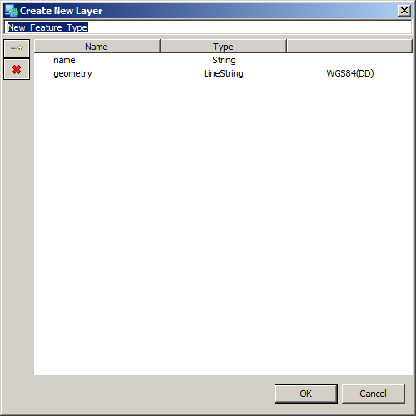

At the top of this box type the name of your layer. Then you must choose the type of layer you will make. It can either be a point, line (lineString), or polygon. If it is going to have many different pieces pick the "Multi...". You choose the type of layer you will make next to where it says "geometry".
The menu pictured above is what you will use to design the table that is going to hold all the details or attributes of your map feature. You can add another attribute by clicking on the button that has a little blue dash and yellow +. Give the attribute a short hand name- like numMembr for number of members and choose the data type. A "string" is text, a "double" is a decimal number, and an "integer" is a whole number. Specifying these types is important if you are doing a lot of analysis with your data. If you are not doing a lot of analysis picking "string" probably will cover your needs.
Once you are done designing the database for your feature. You will see your new layer on your map. You should now begin to draw the new feature. You will need to find the "Create Line Geometries", "Create Point Geometries", or "Create Polygon Geometries" tool which has an icon in the tool bar at the top. Click on the appropriate "Create..." tool and you can begin clicking in the map to draw your shape. After you have finished drawing click on the icon at the top that says "Select and Edit Geometry" when you hover over it. Then click on the "Create Line (or point or polygon) Geometries" tool to draw another one.
As you draw you will notice with every new piece you have another row in your table. You can fill that in as you go or when you are done.
After you complete your layer entirely, right click your new layer in the Layers box the click Export... In the dialog box menu choose layer to shapefile. Find a place to save your shapefile and then you can share it with other cartographers!

Adding other important map elements-
Once you have the map looking usable you can begin to design a version that can be printed or saved and distributed digitally. All maps should have a scale bar, a north arrow, a legend, a title, and a date.
To add a scale bar click on Layer in the main menu at the top and find Scalebar. You will see a scale bar added to your map. You can customize the scale bar by right clicking Scale bar in the Layers box and then clicking change style. You can customize the font, the units (feet, miles, kilometers, etc..), and the number of divisions. Try to think about what would be most intuitive for the viewer.
To add a north arrow click on Layer in the main menu at the top and find North Arrow. You will see a north arrow appear in your map. This is used to verify the orientation of the map for the viewer. It also can add a little more character to the map by choosing a stylish north arrow.
To add a legend click on Layer in the main menu at the top and find Legend. You will see a legend get added to your map. The legend will define all the layers based on the symbols you made.
For the scale bar, legend, and north arrow there are a lot of adjustments you can make by changing the style please experiment so you can make more original looking maps.
Finally, you should add a title and a date to the map. To do this you will change views a little bit. Find a view of the map that you want to show in the printed copy. Then look through the icons at the top- there is one that looks like a piece of paper with a blue ball on it- when you hover over it a little yellow box should say "Creates a page to be printed". Click on that and you will get a menu in which you can choose the size and orientation (landscape or portrait) of the page. Pick one.

The map design view looks like this:
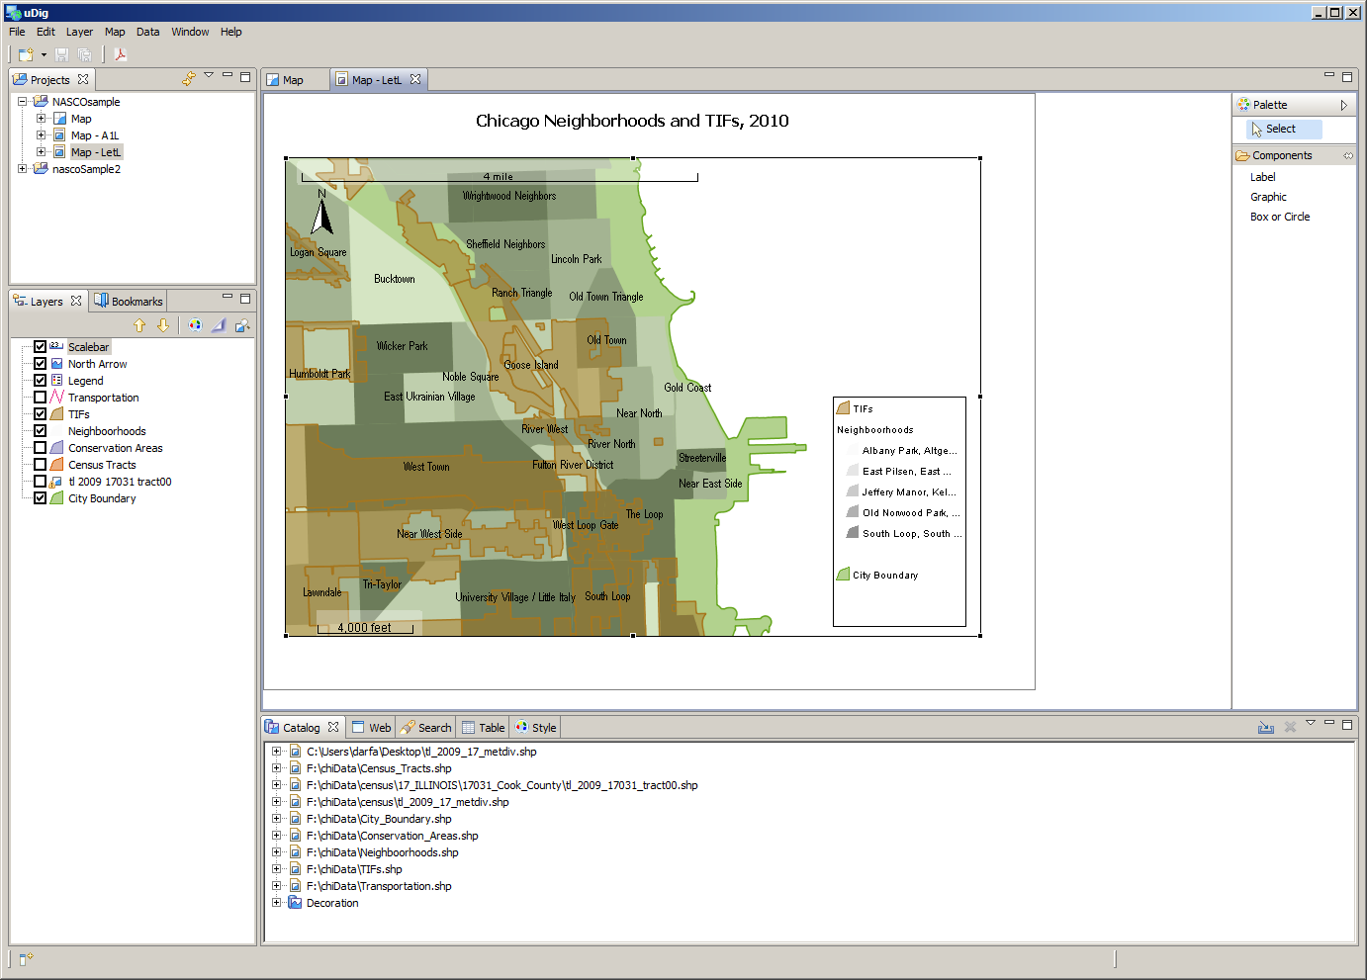
You can add extra labels or graphics with the tools in the narrow box to the right. To change the title click on the text box that says map at the top and write in a title. I suggest writing a date or at least the year too. It may not matter at the moment you make the map but when you look back or someone else looks back at the map you made having a date makes a huge difference.
Once you are done designing your map you can print it by hitting the icon the Adobe acrobat icon at the top. Then choose the location where you want to save the map and it will be saved as a pdf.
DEVELOPING A NETWORK OF GIS DATA FOR COOPS:
These directions are meant to be a tutorial so please try your best to follow along with them when you experiment with using this program.
I am hoping you will experiment and begin to develop shapefiles of your own that represent the needs of your coops and communities. I would love to coordinate sharing of any data you create and answer any questions you have as they come up. Please feel free to eMail me at udthum@yahoo.com or visit my house Stone Soup Cooperative- Ashland House in Chicago. THANKS!

